**Report from the Women’s Committee of the St. Lucia Teacher’s Union**

Report on Gender-Based Violence Workshop

On May 11, 2022, The Women’s Committee of the SLTU, organized a workshop on ‘Gender-Based Violence’ with funding made possible by the Caribbean Union of Teachers (CUT). The workshop was held at the Finance Administrative Center from 9:30am to 3:00pm. The attendees at this workshop included SLTU executive members, members of General Council, members of the Women’s Committee and male and female representatives of the various branches.

The attendees were addressed briefly by the Chair of the Women’s Committee Mrs. Verlina Joseph and by the president of the SLTU Mr. Don Howell.

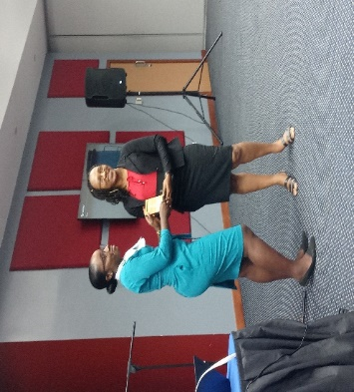

The presenter for session one was Ms. Jasmine Suffren from the CSA, who explained the ILO convention related to Gender-based violence.

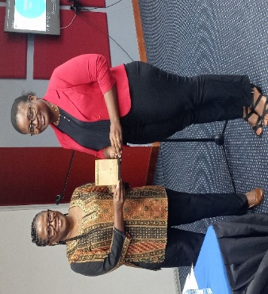

Session two was conducted by Ms. Janey Joseph of the Gender Relations Unit. Ms. Joseph explained the root causes of GBV and the effect that it has on individuals and society.

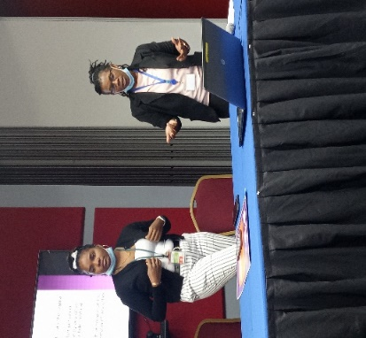 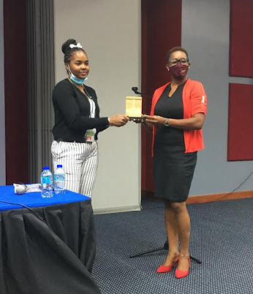

Session 3 was conducted by Cpl 293 Nysa Augustin and Wpc Jean James from the Vulnerable Persons Unit of the Royal St. Lucia Police Force.

There was a high level of interaction and much discussion in every session. The males in attendance notably made a case for sexual harassment on men in the workplace. Their case was supported with many examples.

Feedback from the evaluation sheets distributed after the workshop was very positive. Attendees expressed that the workshop was a very informative and enlightening one. They indicated that more teachers should be exposed to such timely and relevant information.

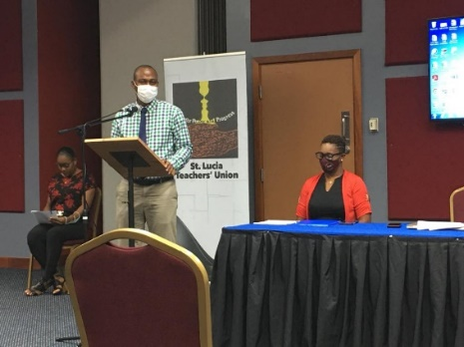 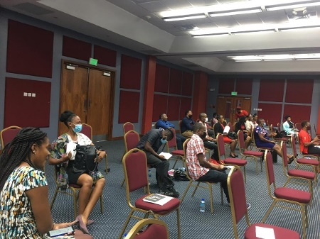

**Report on SLTU Cancer Drive**

The St. Lucia Teacher’s Union Cancer Drive is an annual activity organized by the Women’s Committee of the SLTU. The drive was launched this year on Sunday 9th October at the Teachers Rally in Soufriere.

A total of 96 boxes were prepared and distributed throughout the island. The boxes were distributed to branch representatives who further distributed to Shop stewards in their various branches. Distribution of the boxes to the south of the island proved to be a challenge. Special thanks to sister Sherene Saltibus who assisted the committee in that regard.

The committee used a numbering system to be able to manage and account for the distribution and collection of boxes.

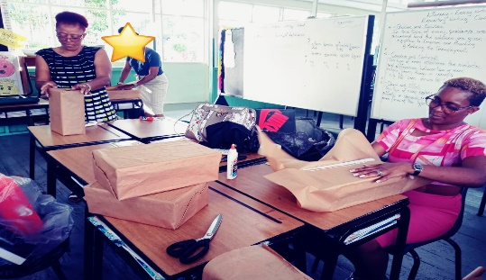

Approval for the activity was granted by SLTU Executive on the 22nd of September, 2022. As a result, boxes did not go out to the schools as early as the committee would have liked. Consequently, schools requested more time to be able to get donations from the students and teachers. The committee requested an extension of the deadline for submission of boxes on the 8th November,2022.

At Shop Stewards workshops held on the 22nd and 23rd of November, some boxes were returned. At these workshops, some Shop Stewards indicated that they had not received boxes from their Branch reps. On the 5th of December, 2022, the committee through the office, sent out a memo to Branch reps. Requesting that all boxes should be returned to the SLTU office before Friday 9th December. The committee also reached out to branch reps directly.

On December 19, 2022, the chair of the Women’s Committee met with the treasurer and two trustees of the SLTU to count the proceeds from the Cancer Drive initiative.

61 boxes from the 96 distributed, were accounted for.

A total of **$5957.50** was collected from the drive.

As it stands presently, 3 more boxes have been returned. A balance of 32 boxes is still outstanding. Assistance have been sought from the SLTU office to reach out to specific branch reps of schools with outstanding boxes. Shop Stewards and Branch reps are urged to follow up with the schools in their branches who have not returned boxes.

**International Women’s Day Conference 2023**

On March 8, 2023, the Women’s Committee of the SLTU celebrated International Women’s Day under the theme: DigitAll: Innovation and Technology for Gender Equality. The conference took place at the Arch Bishop Kelvin Felix Archdiocesan Pastoral Centre. The guest speaker was Ms. Lennel Malzaire Director of Innovation in the Education Department of the Government of St. Lucia.

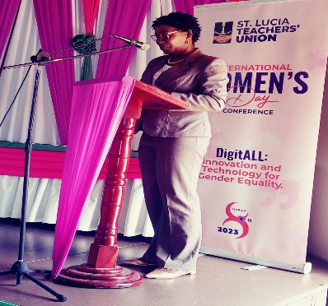

Ms. Rochelle Victor and Mrs. Judy Johannes from the Castries branch were recognized and awarded by the women’s committee for their service to SLTU and their contributions towards the development of women and for the SLTU.

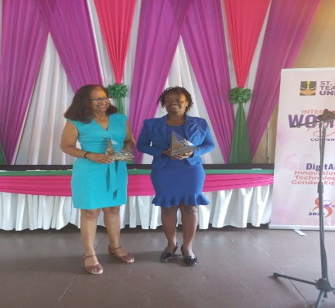

Attendees of the conference were fully engaged in a very interactive and informative session with the team from the Vulnerable Persons’ Unit of the Royal St. Lucia Police Force.

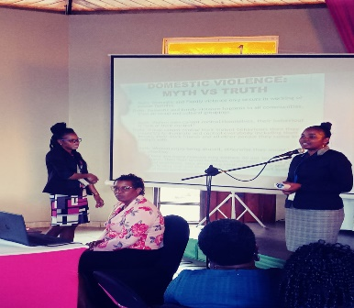

**Energize Her Newsletter**

The sixth edition of the EnergizeHer newsletter was digitally circulated this year. Please look out for it on social media. This edition features a Message from the SLTU president, message from the chair of the Women’s Committee and highlights of various committee activities.

**Moving Forward**

The executive of the women’s committee of the SLTU remains steadfast in our mandate to seek to educate and empower the women of SLTU and to be a source of support for our male counterparts. We endeavor to commit to supporting the activities and events of the SLTU.

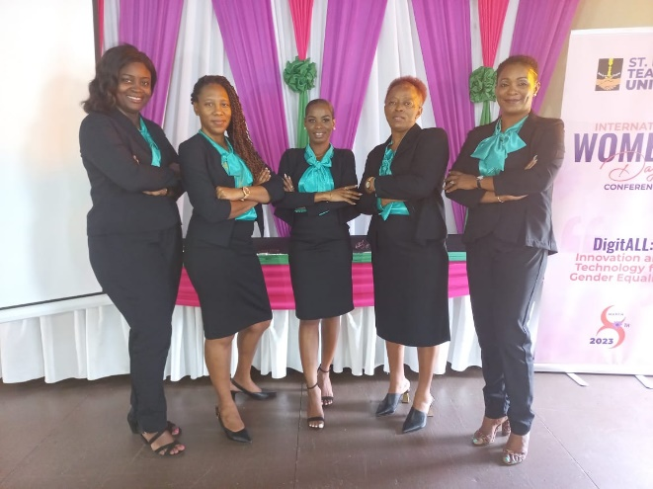

Long live the women of SLTU! Long live the SLTU!